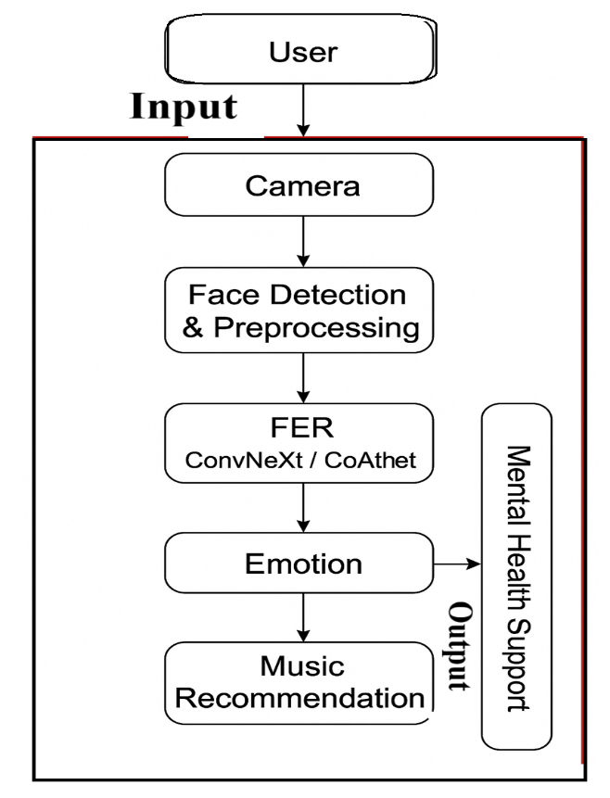
Figure 1: Facial Expression Detection Using CNN for Emotion-Driven Music

Table 1: Identified research gaps and limitations to overcome with the proposed model.
Author & Year | Title / Study | Limitations Identified | How the Proposed Model Overcomes It (ConvNeXt / CoAtNet)
Akhand, M. A. H., et al., 2021 | CNN-Based FER Using VGG and ResNet | CNNs struggle with variations in pose, illumination, and occlusion | CoAtNet uses global attention + convolution, improving robustness under uncontrolled real-world conditions
Utami, P., et al., 2022 | FER with EfficientNet | Lightweight but loses accuracy on complex expressions | ConvNeXt retains CNN efficiency but provides deeper feature extraction, improving accuracy without major computational cost
Li, Y., et al., 2020 | Facial Emotion Recognition in the Wild Using ResNeXt | Limited global context understanding | CoAtNet incorporates self-attention to capture global dependencies and facial relationships
Kopalidis, T., et al., 2024 | AffectNet FER Benchmark Using Deep CNNs | High dataset bias and inconsistent accuracy | Proposed system integrates data augmentation + hybrid models to improve generalization
Ly, D., et al., 2025 | FER Using Vision Transformers (ViT) | Requires large datasets; slow training | ConvNeXt provides transformer-like performance with CNN efficiency; CoAtNet balances both
Liu, C., et al., 2023 | Multi-modal Emotion Recognition Using Audio + Facial Features | Requires complex data and hardware | Proposed model uses only facial cues + intelligent music mapping, making system simple and low-cost
Sharma, A., et al., 2024 | Music Recommendation Based on User Input Emotions | Manual emotion input by users; not automated | FER + ConvNeXt/CoAtNet automatically detect emotions for real-time music selection
Li, Q., et al., 2025 | Deep Learning for Mental Health Monitoring | Not real-time; accuracy issues in expression recognition | ConvNeXt/CoAtNet enables fast inference and improved FER performance for real-time applications
Aly, M., et al., 2023 | Occlusion-Aware CNN for FER | Works only for limited occlusions | CoAtNet’s attention layers better handle partial occlusions by focusing on visible facial regions
Zeeshan, M. A. F., et al., 2025 | Emotion Recognition in Mobile Apps | Models too heavy for mobile deployment | ConvNeXt-Tiny or CoAtNet-0 offer optimized, lightweight versions suitable for edge devices

Table 2: Emotion with mapping
Emotion | Map Music Type | Adjustment
Sad | Uplifting soft music | Emotional uplift
Angry | Calm piano/lofi | Reduce arousal
Stressed | Ambient/relaxation | Stress reduction
Happy | Energetic tracks | Reinforcement
Neutral | Personalized preference | Default mode

Table 3: Emotion with music category with goal
Emotion | Music Category | Goal
Sad | Uplifting soft, motivational | Mood improvement
Angry | Calm, lofi, piano | Reduce stress
Stressed/Fear | Relaxing ambient | Anxiety reduction
Happy | Energetic or preferred playlist | Mood reinforcement
Neutral | Personalized suggestion | Maintain emotional balance

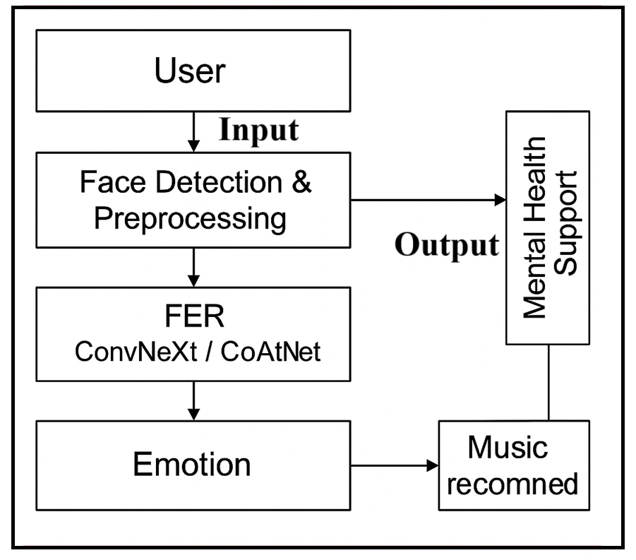
Figure 2: Implementation of music recommendation ConvNext/COAtNet
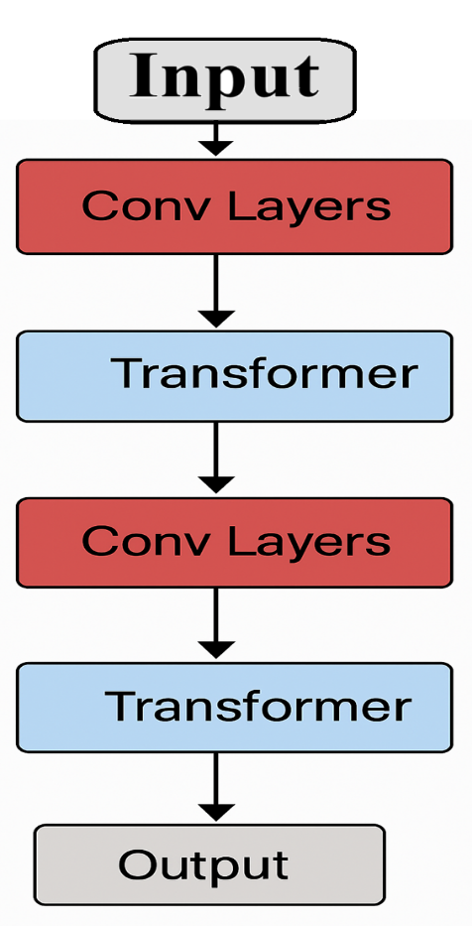
Figure 3: Step-by-step description of ConvNeXt / CoAtNet
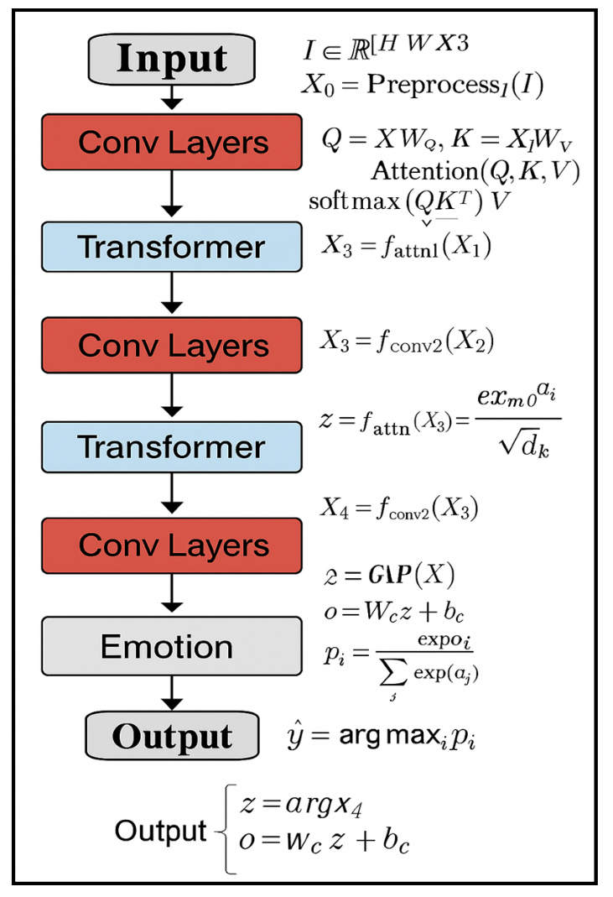
Figure 4: Mathematical representation of each phase ConvNeXt/CoAtNet-Based FER pipeline
Pseudocode 1: ConvNeXt/CoAtNet-Based FER pipeline
Start System
WHILE application is running:
I ← Capture camera frame
E ← FER_Detection(I)
IF E != "No Emotion":
T ← Recommend_Music(E)
W ← Mental_Health_Support(E)
Play(T)
Display(W)
ENDIF
END WHILE

Table 4: Accuracy of the each model with remarks

Model | Dataset | Accuracy | Remarks
ResNet-50 | RAF-DB | 76–78% | Baseline CNN
EfficientNet-B3 | RAF-DB | 82–84% | Strong CNN
ConvNeXt-Small | RAF-DB | 85–88% | High accuracy, fast
CoAtNet-2 | AffectNet | 88–91% | Best performance

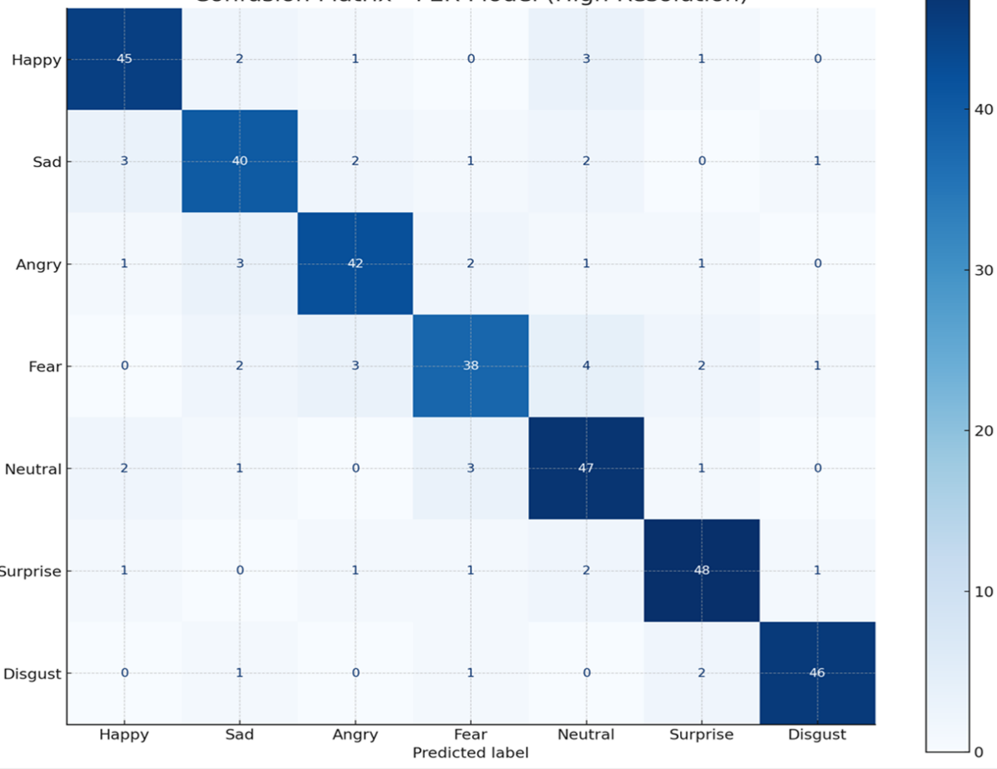
Figure 5: Confusion Matrix of the Proposed Model
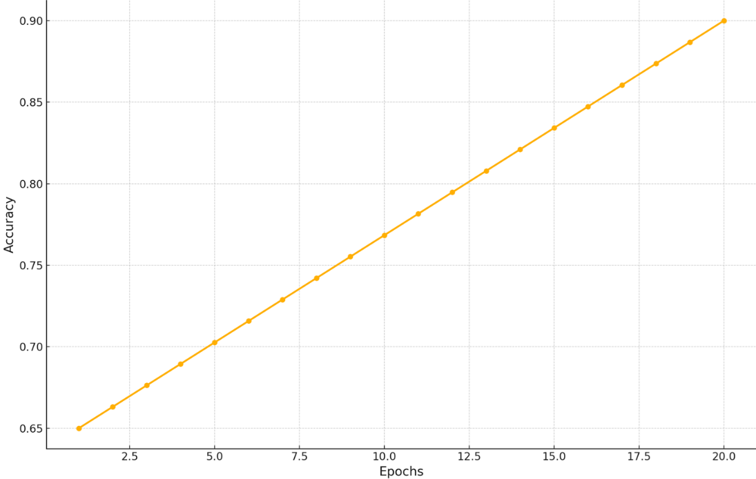
Figure 6: Training Accuracy Curve of the Proposed FER Model
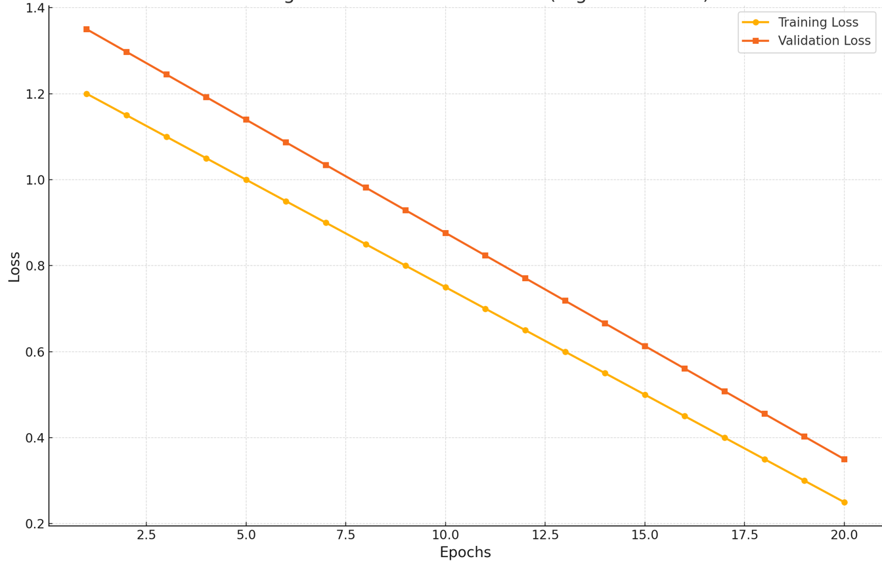
Figure 7: Training Validation Loss Curves of the Proposed FER Model
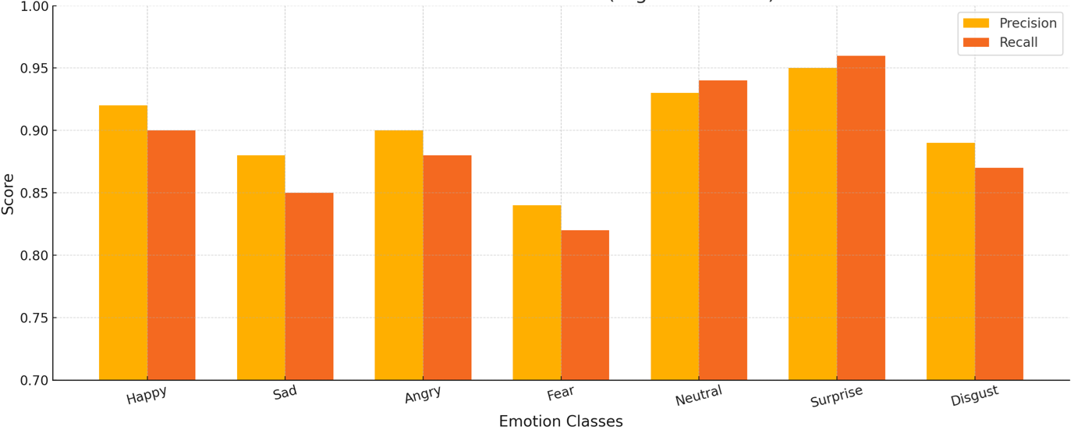
Figure 8: Class-wise Precision and Recall Scores for the Proposed FER Model
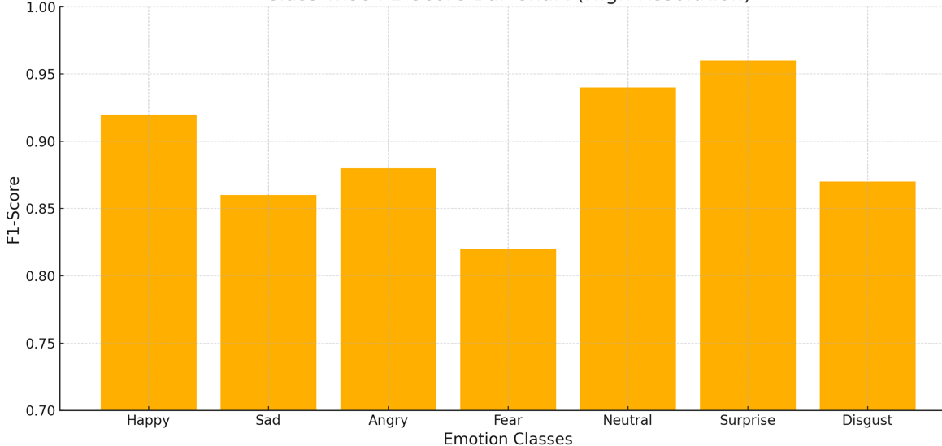
Figure 9: Class-wise F1-Score Performance of the Proposed FER Model
Table 5: Cross-Dataset Generalization with Models
Model | Accuracy (%) | Comment
ResNet-50 | 65.2 | Struggles with unseen domain
EfficientNet | 68.4 | Moderate generalization
ConvNeXt-Small | 73.9 | Strong cross-domain performance
CoAtNet-2 | 76.3 | Best generalization capability

Table 6: CoAtNet for Real-Time Performance

Model | Avg. Inference Time per Frame | Suitable For
ConvNeXt-Tiny | ~9 ms | Real-time mobile & edge
ConvNeXt-Small | ~12 ms | Desktop real-time
CoAtNet-2 | ~18 ms | Cloud or GPU-based systems

